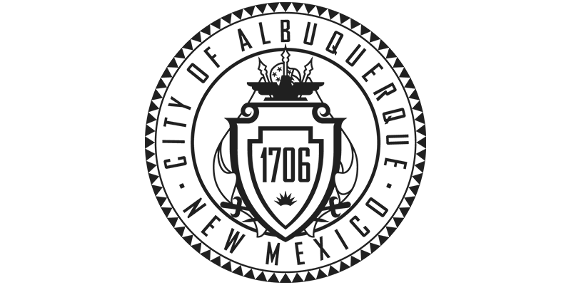City of Albuquerque Property Fact Sheet

Property ID: 100905635508942523, 100905637009142522
Legal Description: S'LY 280 FT OF TR 434 TOWN OF ATRISCO GRANT UNIT #3CONT 1.3100 AC and THE S'LY PORTION OF TR 433 UNIT # 3 TOWN OF ATRISCO GRANTCONT .4879 AC
Acreage: 1.31 & .487
Zoning: PD
Owner Department: Department of Municipal Development

